**POINTER ARITHMETIC**

**ASSIGNMENT # 5**

**Spring 2019**

**CSE102L Computer Programming Lab**

Submitted by: **SHAH RAZA**

Registration No. : **18PWCSE1658**

Class Section: **B**

“On my honor, as student of University of Engineering and Technology, I have neither given nor received unauthorized assistance on this academic work.”

Student Signature: ______________

Submitted to:

**Engr. Madiha Sher**

May 13,2019

Department of Computer Systems Engineering

University of Engineering and Technology, Peshawar

**TASK #1:**

UET is maintaining student attendance records of 10 students by storing roll no, and attendance percentage in 3 different subjects. Write a program to find the average attendance percentage and print the following

a) If attendance percentage >=75 then print student is eligible for writing final exam.

b) If attendance percentage >= 65 and <75 then print student is in condonation list.

c) Otherwise not eligible for writing exams.

**Code:**

#include <iostream>

using namespace std;

void input(int A[3][10]) //Definition of input Function

{

for(int r=0;r<3;r++) //Loop for rows

{

for(int c=0;c<10;c++) //Loop for columns

{

cin>>*(*(A+r)+c); //Array Entry

}

}

}

void Average(int A[3][10]) //Definition of Average function

{

float sum[10]={0},Avg[10];

for(int c=0;c<10;c++) //Loop for columns

{

for(int r=0;r<3;r++) //Loop for rows

{

*(sum+c)+=*(*(A+r)+c); //SUM

}

}

for(int i=0;i<10;i++)

{

*(Avg+i)=*(sum+i)/3.0; //Average

}

for(int i=0;i<10;i++)

{

if(*(Avg+i)>=75)

cout<<"Student "<<i+1<<" is eligible for writing final exam.\n";

else if(*(Avg+i)>=65)

cout<<"Student "<<i+1<<" is in condonation list.\n";

else

cout<<"Student "<<i+1<<" is not eligible for writing final exam.\n";

}

}

int main()

{

int A[3][10]; //Array Declaration

cout<<"Enter the Attendance record of Students: \n"; //Display message

input(A); //Function call

Average(A); //Function call

return 0;

}

**Output (Compilation, testing and debugging):**

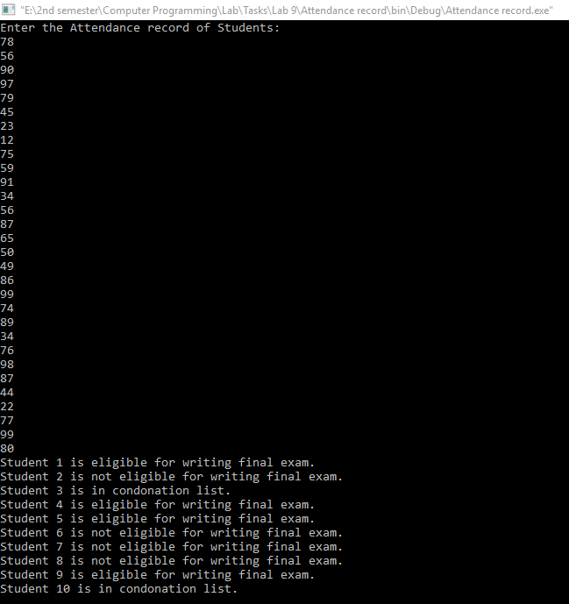

**TASK #2:**

Store the temperature of last 10 days of 3 cities in the database and display for how many days the temperature was below 30 degree and how many days it was above 30 in each city. Find the average temperature of each city and display which city is the warmest.

**Code:**

#include <iostream>

using namespace std;

void input(int A[3][10]) //Definition of input function

{

for(int r=0;r<3;r++) //Loop for rows

{

cout<<"Temperature of city "<<r+1<<endl;

for(int c=0;c<10;c++) //Loop for columns

{

cin>>*(*(A+r)+c); //Array Entry

}

}

}

void AB(int A[3][10]) //Definition of AB function

{

for(int r=0;r<3;r++) //Loop for rows

{

int below=0,above=0; //Variable Declaration

for(int c=0;c<10;c++) //Loop for columns

{

if(*(*(A+r)+c)>30)

above++; //Increment above

else if(*(*(A+r)+c)<30)

below++; //Increment below

}

cout<<"City "<<r+1<<" : Temperature below 30: "<<below<<" Day(s). ";

cout<<"Temperature above 30: "<<above<<" Day(s).\n";

}

}

void Avgtemp(int A[3][10]) //Definition of Avgtemp Function

{

int sum[3][1]={0}; //Array declaration

for(int r=0;r<3;r++) //Loop for rows

{

for(int c=0;c<10;c++) //Loop for columns

{

*(*(sum+r)+0)+=*(*(A+r)+c);

}

cout<<"Average temperature of city "<<r+1<<" : "<<*(*(sum+r)+0)/10.0<<endl;

}

if(*(*(sum+0)+0)>*(*(sum+1)+0)&&*(*(sum+0)+0)>*(*(sum+2)+0))

cout<<"City 1 is the Warmest";

else if(*(*(sum+1)+0)>*(*(sum+0)+0)&&*(*(sum+1)+0)>*(*(sum+2)+0))

cout<<"City 2 is the Warmest";

else if(*(*(sum+2)+0)>*(*(sum+0)+0)&&*(*(sum+2)+0)>*(*(sum+1)+0))

cout<<"City 3 is the Warmest";

else if(*(*(sum+1)+0)==*(*(sum+0)+0)&&*(*(sum+1)+0)>*(*(sum+2)+0))

cout<<"City 1 and city 2 are the Warmest";

else if(*(*(sum+1)+0)==*(*(sum+2)+0)&&*(*(sum+1)+0)>*(*(sum+0)+0))

cout<<"City 2 and city 3 are the Warmest";

else if(*(*(sum+0)+0)==*(*(sum+2)+0)&&*(*(sum+0)+0)>*(*(sum+1)+0))

cout<<"City 1 and city 3 are the Warmest";

else

cout<<"All cities have same temperature.";

}

int main()

{

int A[3][10]; //Array declaration

cout<<"Enter the Temperatures of the three cities: \n";

input(A); //Function Call

AB(A); //Function Call

Avgtemp(A); //Function Call

return 0;

}

**Output (Compilation, testing and debugging):**

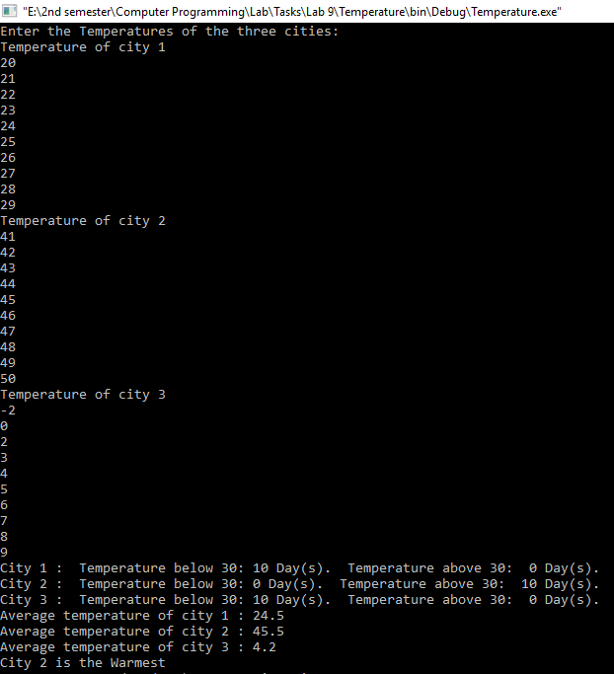

**TASK #3:**

Take a set of N students’ examination marks (in the range 0 to 100) as input, Formulate a program that makes a count of the number of students that passed and failed the examination separately. A pass is awarded for all marks of 50 and above. Display the result position wise.

**Code:**

#include <iostream>

using namespace std;

void input(int A[6]) //input Function Definition

{

for(int i=0;i<6;i++)

{

cout<<"Marks of Student "<<i+1<<" : ";

cin>>*(A+i);

}

}

void PF(int A[6]) //PF Function Definition

{

int pass=0,fail=0; //Variable Declaration

for(int i=0;i<6;i++)

{

if(*(A+i)>=50)

pass++; //Increment Pass

else

fail++; //Increment Fail

}

cout<<"Pass: "<<pass; //Display pass

cout<<"\nFail: "<<fail<<endl; //Display fail

}

void result (int A[6]) //result Function Definition

{

//Bubble Sorting

for(int i=0;i<6;i++)

{

for(int j=0;j<6-1;j++)

{

if(*(A+j)<*(A+j+1))

{

int temp=*(A+j);

*(A+j)=*(A+j+1);

*(A+j+1)=temp;

}

}

}

for(int i=0;i<6;i++)

cout<<*(A+i)<<endl;

}

int main()

{

int A[6]; //Array Declaration

cout<<"Enter the Marks of Students: \n"; //Display message

input(A); //Function Call

PF(A); //Function Call

cout<<"Result Position-wise: \n";

result(A); //Function Call

return 0;

}

**Output (Compilation, testing and debugging):**

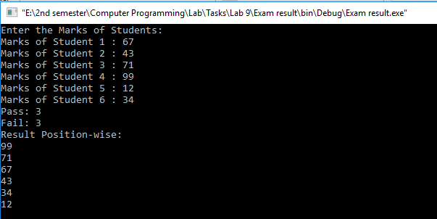

**TASK #4:**

Take an array as input from user and calculate the following:

* 1. Mean
  2. Median
  3. Mode

**Code:**

#include <iostream>

using namespace std;

void input(int A[],int SIZE) //input Function Definition

{

for(int i=0;i<SIZE;i++)

cin>>*(A+i);

}

void bubblesort(int A[],int SIZE) //bubblesort Function Definition

{

for(int i=0;i<SIZE;i++)

{

for(int j=0;j<SIZE-1;j++)

{

if(*(A+j)>*(A+j+1))

{

int temp=*(A+j);

*(A+j)=*(A+j+1);

*(A+j+1)=temp;

}

}

}

}

float Mean(int A[],int SIZE) //Mean Function Definition

{

float sum=0;

for(int i=0;i<SIZE;i++)

sum=sum+*(A+i);

return sum/SIZE;

}

float Median(int A[],int SIZE) //Median Function Definition

{

float med;

if(!(SIZE%2))

{

med=(*(A+(SIZE/2))+*(A+(SIZE/2-1)))/2;

}

else

med=*(A+(SIZE/2));

return med;

}

int Mode(int A[],int SIZE) //Mode Function Definition

{

int number = *(A+0);

int mode = number;

int count = 1;

int countMode = 1;

for (int i=1; i<SIZE; i++)

{

if (*(A+i) == number)

{

++count;

}

else

{

count = 1;

number = *(A+i);

}

if (count > countMode)

{

countMode = count;

mode = number;

}

}

return mode;

}

int main()

{

int SIZE;

cout<<"Enter the size of array: ";

cin>>SIZE;

int A[SIZE]; //Array Declaration

cout<<"Enter an Array: \n"; //Display message

input(A,SIZE); //input Function Call

bubblesort(A,SIZE); //bubblesort Function call

cout<<"Mean: "<<Mean(A,SIZE)<<endl; //Display mean

cout<<"Median: "<<Median(A,SIZE)<<endl; //Display median

cout<<"Mode: "<<Mode(A,SIZE)<<endl; //Display mode

return 0;

}

**Output (Compilation, testing and debugging):**

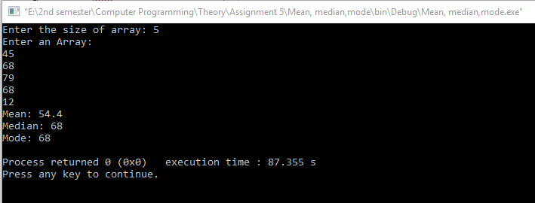

**TASK # 5:**

Write a program that has the following user defined functions:

* 1. Strcmp
  2. Strcat
  3. Strrev
  4. Strlen
  5. Strcpy
  6. Tolower
  7. Toupper

**Code:**

#include <iostream>

using namespace std;

const int SIZE=5;

int strlen(char A[]) //strlen Function Definition

{

int i=0;

for(;*(A+i)!='\0';i++);

return i;

}

void strcmp(char A[],char B[]) //strcmp Function Definition

{

int i=0;

for(;*(A+i)!='\0' && *(B+i)!='\0';i++)

{

if (*(A+i)!=*(B+i))

break;

}

if(i==strlen(A))

cout<<"Strings are equal\n";

else

cout<<"Strings are not equal\n";

}

void strcat(char A[],char B[]) //strcat Function Definition

{

int lA=strlen(A);

int i=lA;

for(int a=0;*(B+a)!='\0';a++,i++)

{

*(A+i)=*(B+a);

}

*(A+i)='\0';

}

void strrev(char A[]) //strrev Function Definition

{

for(int i=strlen(A)-1;i>=0;i--)

cout<<*(A+i);

}

void strcpy (char A[],char B[]) //strcpy Function Definition

{

int i=0;

for(;*(B+i)!='\0';i++)

{

*(A+i)=*(B+i);

}

*(A+i)='\0';

}

void Tolower(char A[]) //Tolower Function Definition

{

for(int i=0;*(A+i)!='\0';i++)

{

if (*(A+i)>='A'&&*(A+i)<='Z')

*(A+i)=*(A+i)+32;

}

}

void Toupper(char A[]) //Toupper Function Definition

{

for(int i=0;*(A+i)!='\0';i++)

{

if (*(A+i)>='a'&&*(A+i)<='z')

*(A+i)=*(A+i)-32;

}

}

int main()

{

char A[SIZE],B[SIZE]; //Array Declaration

cout<<"Enter string 1: "; //Display message

cin>>A; //input Array A

cout<<"Enter string 2: "; //Display message

cin>>B; //input Array B

cout<<"Comparison: "; //Display message

strcmp(A,B); //Function Call

strcat(A,B); //Function Call

cout<<"After Concatenation: "<<A; //Display message

cout<<"\nAfter Reversing: "; //Display message

strrev(A); //Function Call

Tolower(A); //Function Call

cout<<"\nLower case A: "<<A; //Display message

Toupper(A); //Function Call

cout<<"\nUpper case A: "<<A; //Display message

strcpy(A,B); //Function Call

cout<<"\nAfter Copying B to A: "<<A; //Display message

return 0;

}

**Output (Compilation, testing and debugging):**

